11: Preprocessing, Analysis and Visualization
As part of data preprocessing, you have to identify different types in the array. You may be required to create subarrays of a specific data type in order to carry out, for example, mathematical operations and visualization. list1 = ["34", "name", "45", "is", "100"]
- Using NumPy, create an array using the list above. Write a code to check how many non-numeric elements are in the list.
- Using NumPy, write code to sum all the numeric elements in the list.
- Using NumPy, write code to square all the numeric elements in the array you created in question 1. Return an array of squared elements.
- You have the following lists:

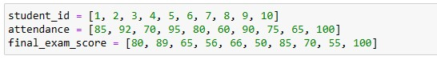

Using NumPy, create an array using the lists above. Each list must be a row in the array. Your array must have 3 rows and 10 columns. To visualize the correlation between attendance and the final_exam_score, create a scatter plot using Matplotlib. Set the final_exam_score the x-axis and attendance as the y-axis of your scatter plot. Use the NumPy array you just created as the source of your data for the plot.
b. By visualizing your scatter plot (question 4a), what final score was the outlier of the data?

